|  |  |  |
| --- | --- | --- |
|  | October First Thursday Match  **Stage 1**  **Not A Lot of Danger**  Designed by Ike Starnes  Credit to Brenda Taylor Hammer-Down Practical Shooters |  |
| **START POSITION:** Standing anywhere inside the shooting area.  **HANDGUN:** Handgun is loaded and holstered, wrists below belt.  **PCC:** PCC is loaded, stock on shoulder, strong hand wrist below belt, muzzle pointed downrange. | | **SCORING:** Comstock, 26 rounds, 130 points  **TARGETS:** 13 USPSA paper targets  **SCORED HITS:** 2 Best hits per target will be scored  **START-STOP:** Audible - Last shot  **RULES:** Current USPSA Rules |
| **STAGE PROCEDURE:** Engage targets from within the shooting area. | |

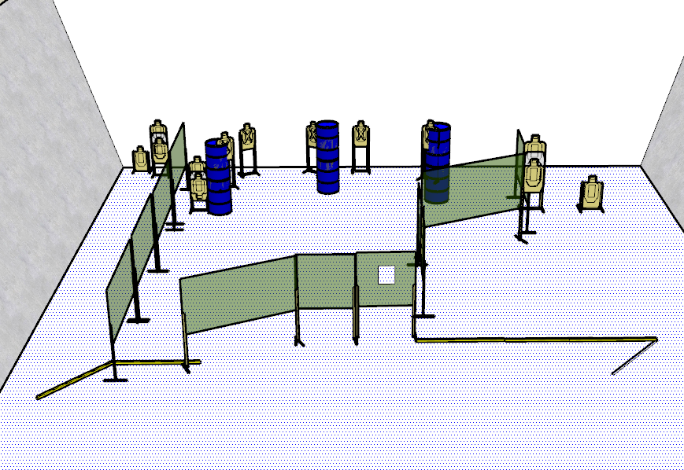

**WRITTEN STAGE BRIEFING:**

**Stage 1 – Not A lot of Danger** is a 26-round, 130 point, Comstock Long Course. There are 13 USPSA targets and the best 2 hits per target will be scored.

**Handgun start position** is standing anywhere inside the shooting area with wrists below belt. The handgun is loaded and holstered.

**PCC start position** is standing anywhere inside the shooting area with stock on shoulder, and strong hand wrist below belt, muzzle pointed downrange. PCC is loaded.

On the audible start signal, engage targets from within the shooting area.